Jonathan Sligh Assignment 4

The overflow was happening and it was prone to buffer attacks because the new string in the strcpy wasn’t big enough to hold the recvBuff which caused a segmentation fault and could send back extra memory to the client, so to fix it I did:

In server.c I created a new string (newStr) that was the size of the received buffer and then copied the recvBuffer into the new string which was the correct size of what was received. I then sent the new string to the client. I did not change anything in client.c

Server.c: Included lines (created new appropriately sized string): char newStr[numBytes];

Server.c: Modified send function to send back new string: send(clntSockfd, newStr, strlen(newStr), 0)

Server working correctly (2 screenshots):

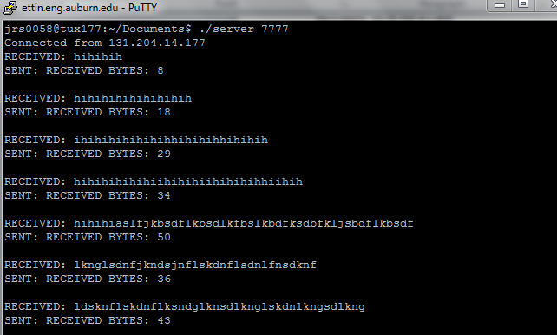

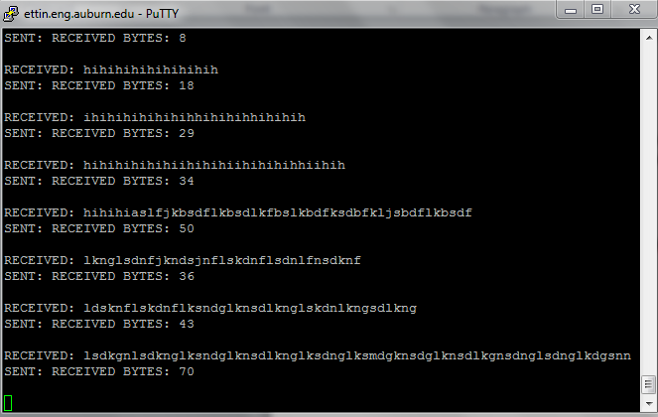

Client with server working correctly (2 screenshots):

